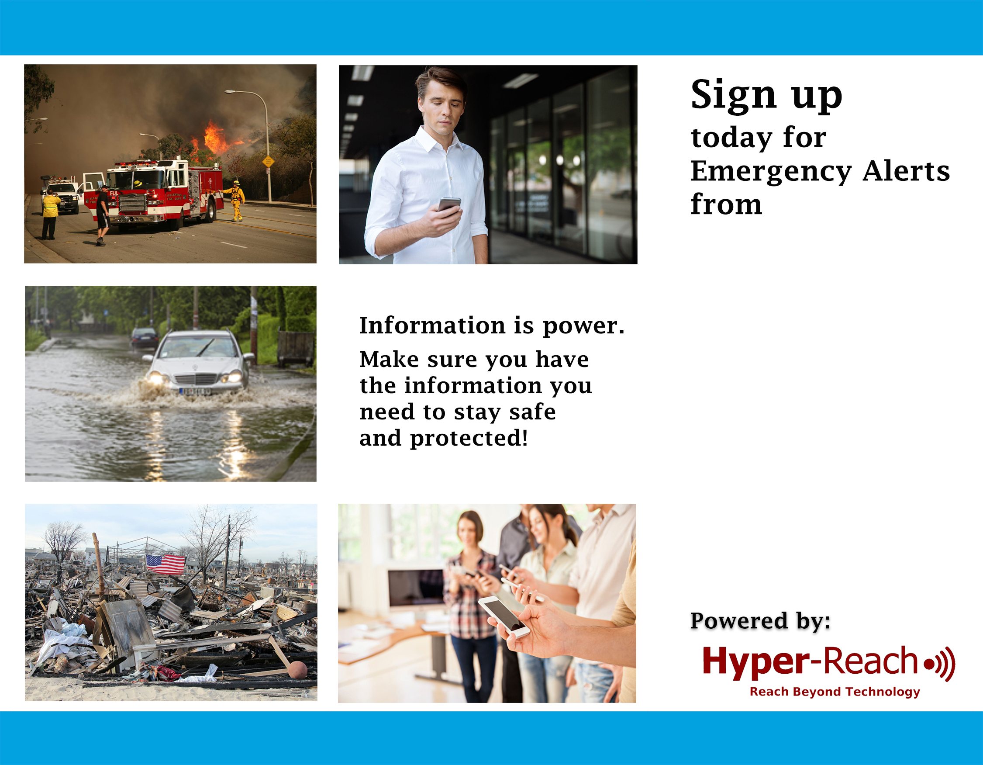
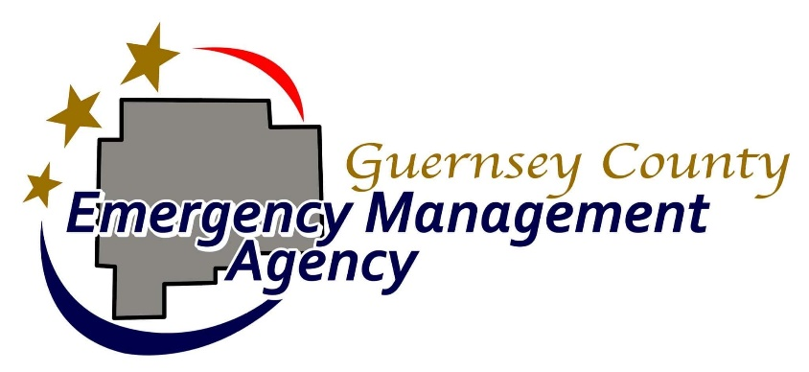

5 Ways to Sign Up:

- Scan QR Code:
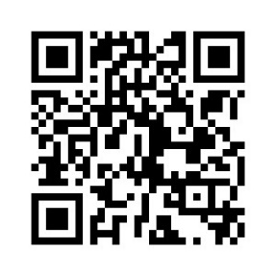

- Go to:

http://hyper-reach.com/ohguernseysignup.html

- Call:

740-638-0898

- Text “alerts” to

740-638-0898

- Tell your Alexa unit “Alexa, enable Hyper-Reach”

